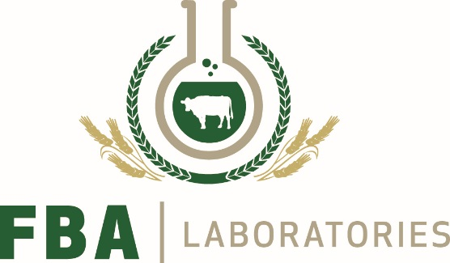

BVD Ear Notch Testing Form
Customer Name: Date:
Customer Address: Herd ID: IE
Negative Herd Status Yes No Please Tick

Contact Number:
Email Address:
All Samples must be prepaid:

NHS €2.80 per sample, must pay for herd upfront.
Minimum Payment is €20.00. No coins accepted.
FBA will not accept any responsibility for cash lost in transit.
Quantity to be  Tested | Description | Unit Price | Total €
 | BVD Ear Notch  Sample Test | €2.80 (incl. VAT) NHS  Minimum payment €20.00
Payment Type
Cheque Visa Card Mastercard Laser Card
Card Number:

Expiry Date: Security Code:
Last 3 digits on the back of card

Name on Card: __________________________
AS SPELT ON CARD
Please return samples for testing and payment to:
FBA Laboratories Ltd, Carrigeen Industrial Estate, Cappoquin, Co. Waterford
If posting samples please note the minimum postage is €1.25 for between 1 and 8 samples.

Tel: 058 52861 Fax: 058 52865 Visit our website: www.fba-labs.com Vat No: 8250639u

